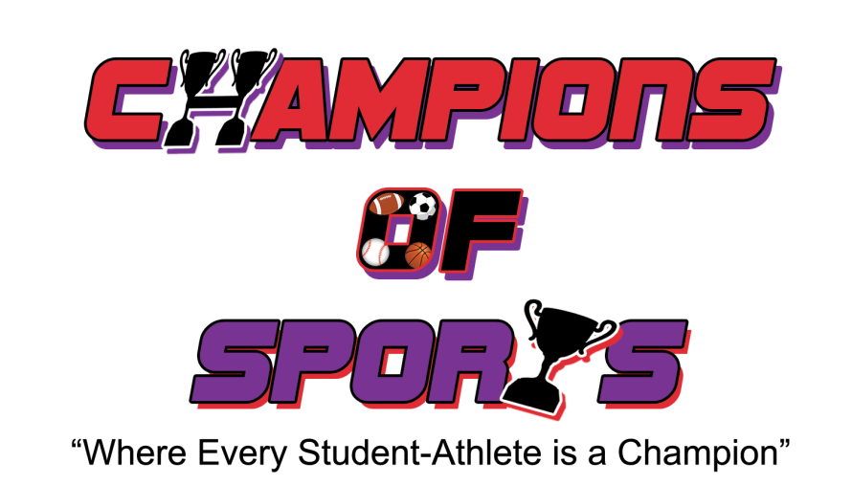

We recognize the possibility of physical injury associated with the sport of basketball. We release Champions of Sports and their officers, directors, coaches, employees, agents, volunteers, sponsors, participating athlete, other parents, representatives and successors and the schools, school districts, religious organizations and other owners of the facilities where games/practices are held and their employees (all forging are collectively referred to herein as the Champions of Sports Parties), from any and all liabilities, claims, damages,, and expenses, whether known or unknown, sustained by the player or by the undersigned which in any way arise out of, or are connected with or relate to the participation by the player in any activity (including without limitation transportation to and from activities) organized by or in any way associated with Champions of Sports. We hereby indemnify Champions of Sports parties from and hold each of them harmless against any and all losses, liabilities, claims, damages and expenses which any of them pay suffer or incur arising out of or resulting from the players participation in any activities of Champions of Sports or the breach by the undersigned, by the player or by any member of the family of the undersigned or the player, as the case may be, of the Rules and Regulations or the Agreement.

Team Name:

Team Coach: Date;

Tournament Director: Event:

